**The Project Proposal – LinkedIn Data Analysis**

**To:** William Cunningham, INFT2007 Instructor

**From:** Cuong Hoang – IT Data Analytics 2021 Student

**Date:** January 21st, 2021

**Subject:** LinkedIn data project proposal

**I. Project Charter**

**1. What is the essence of the project?**

By planning either a technical or non-technical plan in the GANTT chart, we will reach these goals as bellow:

* Create a searchable webpage to help the HR department to find data of Data Analysts or data-related employees geographically from Linked faster and more effectively.
* Using data visualization in a form of a web app to support educational institutions in designing data-related programs curriculums based on what skills that those people on Linked possess.
* To answer the fundamental question of what skills a person needs to work as a Data Analyst, Data Engineer or Data Scientist.
* Gaining some insight by testing a hypothesis between technical and non-technical skills of those employees on Linked

**2. Why does this project exist?**

* Based on the request of some HR managers, academic chairs of some colleges, and the curiosity of educational institution applicants, the project will either solve some actual problems or support the decision-making process.
* It is just a small and simple project but has the potential of being developed, extended, or funded.
* Not only the project will answer some practical questions in the organizational environment, but it is also a relevant topic for Data Analyst.
* The project applies nearly all outcomes of NSCC Data Analytics courses in the first two semesters.

**II. Project Scope Statement**

* Data crawling: Crawl data of data-related employees (Data Analyst, Data Engineer and Data Scientist) on Linked in North America (Canada, America, Mexico). The data are included but not limited to name, LinkedIn URL, location, skills, and endorsement.
* Data cleaning: Clean all data for this project purposes, minimalize and structuralize the data to SQL server.
* Provide the user-friendly deliverables of a SQL server database, a searchable database webpage and a web app for data visualization.
* Answer questions and verify hypothesis using data visualization.

**III. My Scope Statements**

* Being familiar with project management as a project manager
* Master self-learning skill
* Working with minimal supervision and being born-ready by picking up some courses, YouTube videos needed to perform the tasks assigned or needed to be done even though I do not know how to do them initially.

**IV. My Initial Plan**

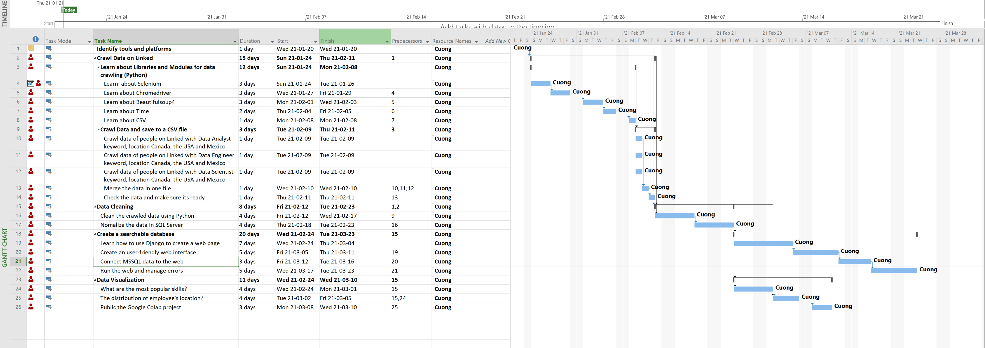

**V. My Learning Expectations**

- Know how to plan and manage a project

- Know how to perform all tasks, a project manager sometime does not know to do all tasks but better to know all

- Understand the concept of data mining, data cleaning, data transition

- Identify the roles of members in the project and know the so-call full-stack Data Analyst.